weekly assignment – 2
- create client master table
create table client_master (
clientno varchar(6) primary key,
name varchar(20) not null,
address1 varchar(30),
address2 varchar(30),
city varchar(15),
pincode bigint,
state varchar(15),
baldue decimal(10,2),
check (clientno like 'c%')
);
- create product master table
create table product_master (
productno varchar(6) primary key,
description varchar(15) not null,
profitperc decimal(4,2) not null,
unitmeasure varchar(10) not null,
qtyonhand int not null,
reorderlvl int not null,
sellprice decimal(8,2) not null,
costprice decimal(8,2) not null,
check (productno like 'p%'),
check (sellprice > 0),
check (costprice > 0)
);
- create salesman master
create table salesman_master (
salesmanno varchar(6) primary key,
salesmanname varchar(20) not null,
address1 varchar(30) not null,
address2 varchar(30),
city varchar(20),
pincode bigint,
state varchar(20),
salamt decimal(8,2) not null,
tgttoget decimal(6,2) not null,
ytdsales decimal(6,2) not null,
remarks varchar(60),
check (salesmanno like 's%'),
check (salamt > 0)
);
- create sales order table
create table sales_order (
orderno varchar(6) primary key,
clientno varchar(6),
orderdate date,
delyaddr varchar(25),
salesmanno varchar(6),
delytype char(1),
billedyn char(1),
delydate date,
orderstatus varchar(10),
check (orderno like 'o%'),
check (delytype in ('p','f')),
check (billedyn in ('y','n')),
check (orderstatus in ('in process','fulfilled','backorder','cancelled')),
foreign key (clientno) references client_master(clientno),
foreign key (salesmanno) references salesman_master(salesmanno)
);
- create sales order details
create table sales_order_details (
orderno varchar(6),
productno varchar(6),
qtyordered int,
qtydisp int,
productrate decimal(10,2),
primary key (orderno, productno),
foreign key (orderno) references sales_order(orderno),
foreign key (productno) references product_master(productno)
);

- insert into client_master
(clientno, name, city, pincode, state, baldue)
values
('c00001', 'ivan bayross', 'mumbai', 400054, 'maharashtra', 15000.00);

- insert into client_master
(clientno, name, city, pincode, state, baldue)
values
('c00002', 'rohit sharma', 'pune', 411001, 'maharashtra', 8000.00);

- insert into product_master
(productno, description, profitperc, unitmeasure, qtyonhand, reorderlvl, sellprice, costprice)
- values
('p00001', 't-shirts', 5.00, 'piece', 200, 50, 350.00, 250.00);

- insert into product_master
(productno, description, profitperc, unitmeasure, qtyonhand, reorderlvl, sellprice, costprice)
values
('p00002', 'jeans', 8.00, 'piece', 150, 40, 1200.00, 900.00);

- insert into salesman_master
(salesmanno, salesmanname, address1, city, pincode, state, salamt, tgttoget, ytdsales, remarks)
values
('s00001', 'aman', 'a/14', 'mumbai', 400002, 'maharashtra', 3000.00, 100.00, 50.00, 'good');

- insert into salesman_master
(salesmanno, salesmanname, address1, city, pincode, state, salamt, tgttoget, ytdsales, remarks)
values
('s00002', 'neha', 'b/21', 'pune', 411002, 'maharashtra', 3500.00, 120.00, 70.00, 'excellent');

- insert into sales_order
(orderno, orderdate, clientno, delytype, billedyn, salesmanno, delydate, orderstatus)
values
('o19001', '2002-06-12', 'c00001', 'f', 'n', 's00001', '2002-07-20', 'in process');

- insert into sales_order
(orderno, orderdate, clientno, delytype, billedyn, salesmanno, delydate, orderstatus)
values
('o19002', '2002-06-15', 'c00002', 'p', 'y', 's00002', '2002-07-25', 'fulfilled');

- insert into sales_order_details
(orderno, productno, qtyordered, qtydisp, productrate)
values
('o19001', 'p00001', 4, 4, 525.00);

- insert into sales_order_details
(orderno, productno, qtyordered, qtydisp, productrate)
values
('o19002', 'p00002', 2, 2, 1250.00);

--1. display the names of all the clients

select name from client_master;
o/p:
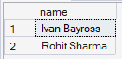

--2. display all the clients who are located in mumbai

select name from client_master where city = 'mumbai';
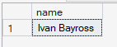

--3. display all the products whose selling price is ≥ 200 and < 5000

select * from product_master where sellprice >= 200 and sellprice < 5000;

--4. display name, city and state of clients not in maharashtra

select name,city,state from client_master where state != 'hyd';

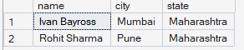

--5. display all the information of client no c0001 and c0002

select * from client_master where clientno = 'c00002' or clientno = 'c00001';
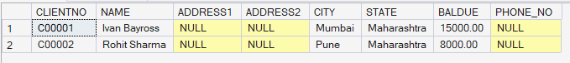

--6. change the selling price of '1.44 drive' to ₹1150.50

update product_master set sellprice = 1150.50 where description = 'jeans';

--7. delete the record of client_no c00005

delete from client_master where clientno = 'c00005'

--8. display the clients who stay in a city whose second letter is 'a'

select name from client_master where state like '_a%';
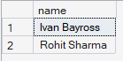

--9. count the number of products having price ≥ 1500

select count(*) from product_master where sellprice >= 500

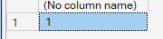

--10.display qtyordered, qtydisp and balanceqty (not in table)
--balanceqty = qtyordered – qtydisp

select qtyordered, qtydisp , (qtyordered-qtydisp) as balanceqty from sales_order_details

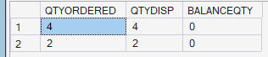

--1.make clientno as primary key in client_master

alter table client_master add primary key(clientno)

--2.add a new column phone_no in client_master

alter table client_master add phone_no varchar(10);

--3.add not null constraint in product_master

alter table product_master alter column description varchar(15) not null;
alter table product_master alter column profitperc decimal(8,2) not null;
alter table product_master alter column sellprice decimal(8,2) not null;
alter table product_master alter column costprice decimal(8,2) not null;

--4.change size of name column to 60 in client_master

alter table client_master alter column name varchar(60)

--5.remove pincode column from client_master

alter table client_master drop column pincode;

--1.find the products sold to ivan bayross

select distinct p.productno,p.description
from client_master c
join sales_order s on s.clientno = c.clientno
join sales_order_details sod on s.orderno = sod.orderno
join product_master p on p.productno = sod.productno
where c.name = 'ivan bayross'

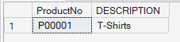

--3.list productno and description of constantly sold products

select p.productno , p.description from product_master p
join sales_order_details sod on sod.productno = p.productno
group by p.productno , p.description
having count(sod.orderno) > 1;

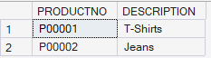

--4.find names of clients who purchased 'trousers'

select c.name from client_master c
join sales_order s on c.clientno = s.clientno
join sales_order_details sod on s.orderno = sod.orderno
join product_master p on p.productno = sod.productno
where description = 'jeans'
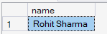

--5.list products and orders from customers who ordered less than 5 units of 'pull overs'

select p.productno ,p.description ,sod.orderno, sod.qtyordered from sales_order so
join sales_order_details sod on sod.orderno = so.orderno
join product_master p on p.productno = sod.productno where p.description = 'jeans' and sod.qtyordered < 5;

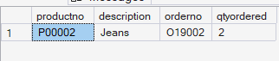

--1.finding the non-moving products (products not being sold)

select productno,description from product_master
where productno not in (select distinct productno from sales_order_details)

--2.find the name and complete address of the customer who placed order no = 'o19001'

select name,address1,address2,city,state from client_master
where clientno = (select clientno from sales_order where orderno = 'o19001')
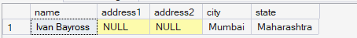

--3.finding the clients who placed orders before may 2002

select name from client_master where clientno in (select clientno from sales_order where
orderdate < '2002-05-01')
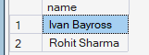
--2.display balance due from client master as $99,999.99

select format(baldue, '$#,##0.00') as balance_due
from client_master;
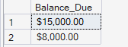

--3.display message "salesman aman sold goods of 50 while given target was 100."

select 'salesman aman sold goods of 50 while given target was 100.' as message;
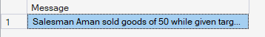

--4. display your age in years

select datediff(year,'2004-10-09',getdate()) as diff
